How to Change an Email Signature in Microsoft Outlook Exchange
Instructions: Follow the steps below in order to update or add a new email signature.

- Within Microsoft Exchange, click the gear icon in the top menu.
- Select Options.
- Select Email signature nested within the Mail > Layout label groups.
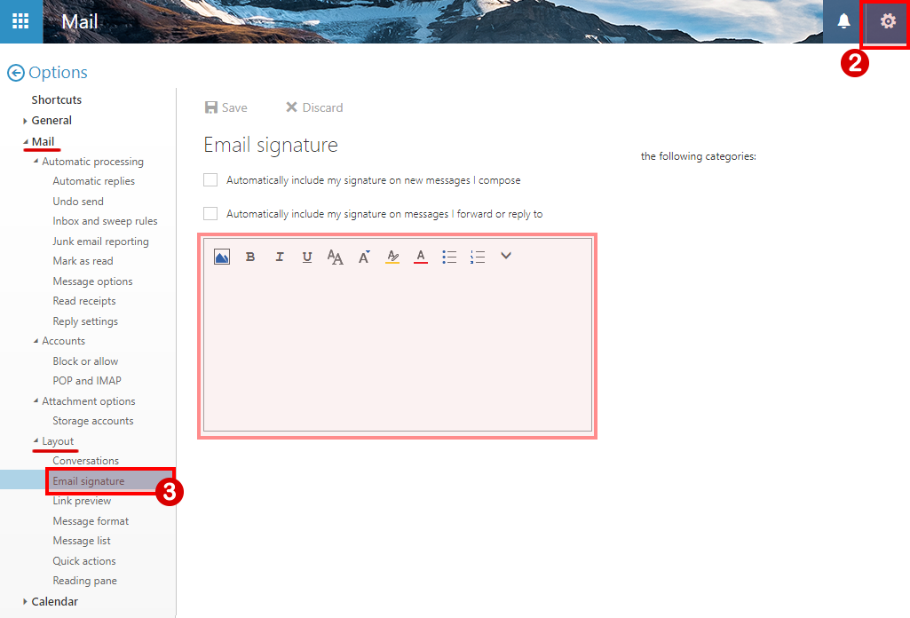
Continue reading…

- The email signature will be created in three sections: details, logo, and address.
Please follow these steps accordingly in the next outline of steps:
Section 1: Details
Instructions: Copy and paste the literal e-mail signature details content into your signature email settings. Please choose the content appropriate for your use from the table below:
 | For Staff | For Faculty  (select best of 3 options)
Option 1 | Name  Title | Department  Main: 734-462-XXXX  Direct: 734-462-XXXX | Name  Biology Professor  Main: 734-462-XXXX  Direct: 734-462-XXXX
Option 2 | n/a | Chair of the English Department | Liberal Arts  English Professor  Main: 734-462-XXXX  Direct: 734-462-XXXX
Option 3 | n/a | Name, PhD  Discipline  Main: 734-462-XXXX  Direct: 734-462-XXXX
After inserting this details text into your signature, keyboard a hard “enter” to move your cursor to the next line where we will insert the logo graphic in the next step.
Continue reading…

- Section 2: Logo
Newer versions of Outlook Exchange do not copy/paste over graphics; therefore, we will need to upload the logo graphic into the signature. To do this, you will need the logo graphic.
Instructions:
  - First we will save the logo graphic to your computer. Right-click the logo graphic within this document below and select Save As Picture to save this image file to your computer. It is recommended you simply save this to your desktop location.
Logo Graphic:
  - Next, we will upload this graphic into your signature. Within Outlook Exchange, ensure cursor positioning is at the next empty line. Select the image icon, and open the logo graphic file you just saved from your desktop location, called logo-email-signature.png.
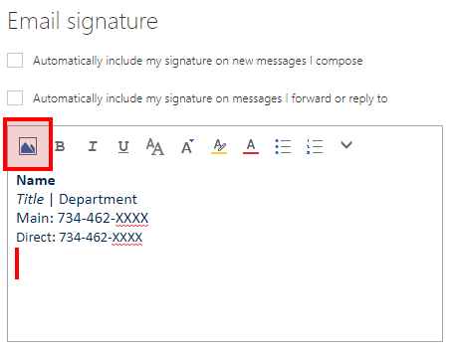
  - After inserting the logo graphic, keyboard a hard “enter” to move the cursor position to the next line where we will lastly insert the address information.
Continue reading…

- Section 3: Address
Instructions: Copy and paste the literal e-mail signature address content into your signature email settings. Please choose the content appropriate for your use from the table below:
Address 1 | 18600 Haggerty Rd., Livonia, MI 48152-2696  schoolcraft.edu
Address 2 | 1751 Radcliff St., Garden City, MI 48135  schoolcraft.edu
Address 3 | 31777 Industrial Road, Livonia, MI 48150  schoolcraft.edu

- We have a completed signature! Lastly, be sure to keep this hard work by clicking Save.
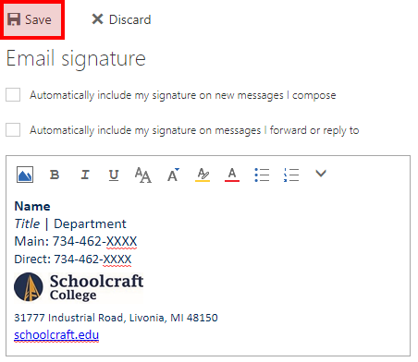

Great work, thank you! I know there were a lot of steps involved here. We appreciate your dedicated help in keeping our brand consistent.

